Cross-belt unit
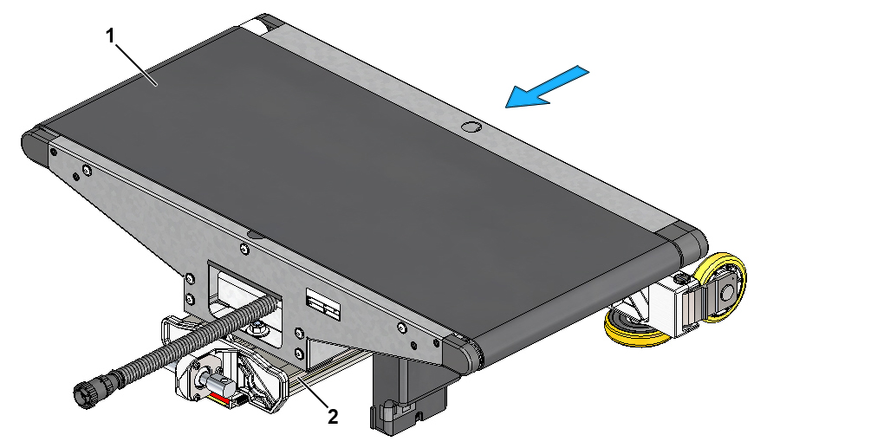
Fig. 1-1 Cross-belt unit mounted on longitudinal profile of cart
1. | Cross-belt unit
2. | Cart, longitudinal profile

Preparation necessary
The sorter frame must be installed and the train of carts put in place before cross-belt units can be fitted.

Tools
Supplied TT/CB Customer Tool Kit

Guides
None

Special safety instructions
The same safety instructions regarding magnetism apply to the installation of cross-belt units as to the installation of carts.
See the special safety instructions in the installation guide for carts.

Installation guide

Installation of current collector unit
A number of the cross-belt units have to be equipped with a current collector. The current collector is not fitted at the factory because of the risk of it being damaged in transit.
The wiring of these cross-belt units is ready for a current collector to be connected.
.1 Turn the cross-belt unit over.
.2 Position the current collector unit on the steel frame opposite the gearbox as shown in Fig. 1-2.
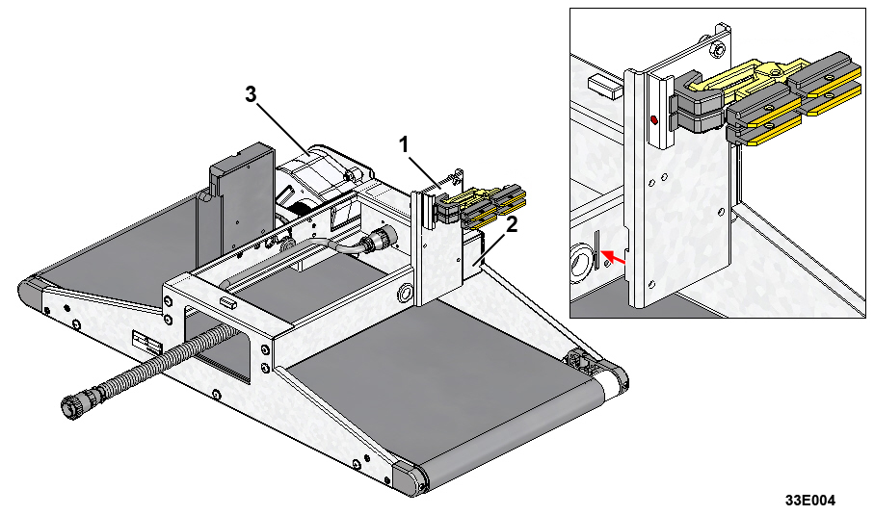
Fig. 1-2 Positioning of current collector unit
1. | Current collector unit
2. | Steel frame
3. | Gearbox with motor

.3 Secure the current collector unit to the steel frame as shown in Fig. 1-3.
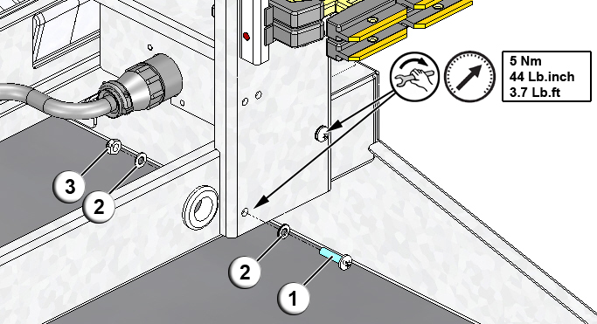
Fig. 1-3 Securing current collector unit
1. | Screw
2. | Washer
3. | Locknut

.4 Connect the current collector cables to the brushes as shown in Fig. 1-4.

 | The cable marked with red tape must be connected to the top brush (marked with a red dot).  Please note that the cross-belt unit is upside down in Fig. 1-4 below, so the top brush is facing down.

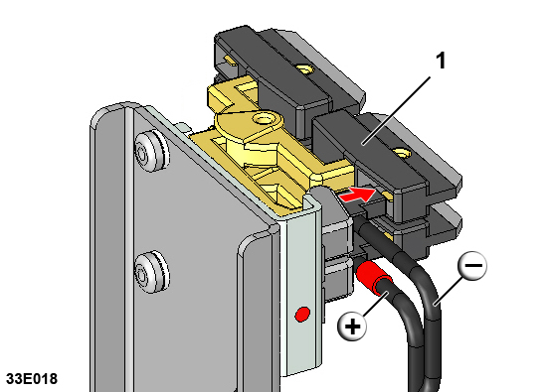
Fig. 1-4 Connection of current collector cable to brush
1. | Brush

.5 Secure the current collector cables to the current collector unit with a cable tie as shown in Fig. 1-5.

Make sure that the yellow mark on the current collector cable is under the cable tie before the tie is tightened. This ensures that the current collector cable is positioned in such a way that the current collector brushes have full range of movement.

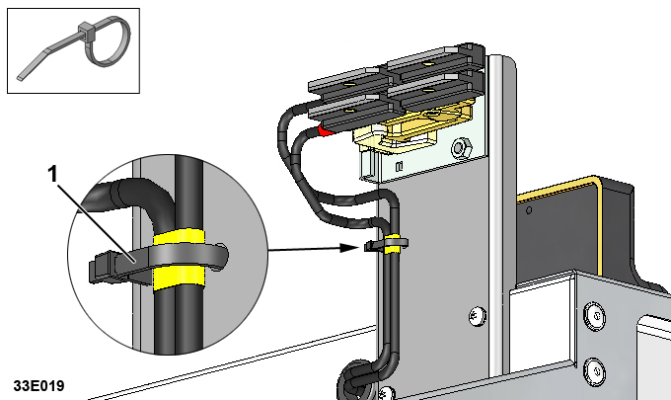
Fig. 1-5 Attachment of current collector cable
1. | Yellow mark on current collector cable

Installation of cross-belt unit

A number of the cross-belt units are equipped with a current collector unit (see chapter 1.5.1). Cross-belt units with a current collector unit should be distributed around the train of carts at regular intervals.
The current collector unit does not affect installation of the cross-belt unit in any other way.

.1 Put a cross-belt unit on the cart with the MCB on the left-hand side as seen in the direction of travel.
.2 Position the cross-belt unit on the cart’s longitudinal profile as shown in Fig. 1-6 and Table 1-1.
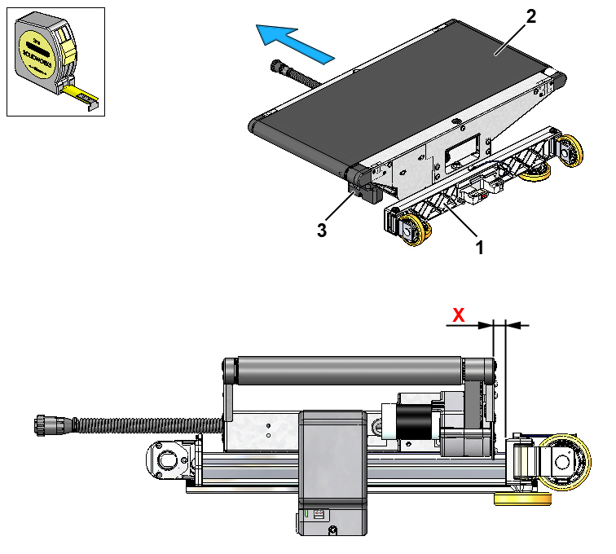
Fig. 1-6 Positioning of cross-belt unit on cart
1. | Cart
2. | Cross-belt unit
3. | MCB

Table 1-1 Positioning dimensions for cross-belt units, belt length 800mm
Belt width (BW) | Cart pitch (Cp) | Positioning dimension (X)  See Fig. 1-6
350 mm | 600 mm | 18 ±1 mm
500 mm | 700 mm | 7 ±1 mm

.3 Screw the T-head bolts down into the track on the cart’s longitudinal profile and turn them into locked position.
.4 Tighten the T-head bolts through the two holes in the top of the cross-belt unit as shown in Fig. 1-7.
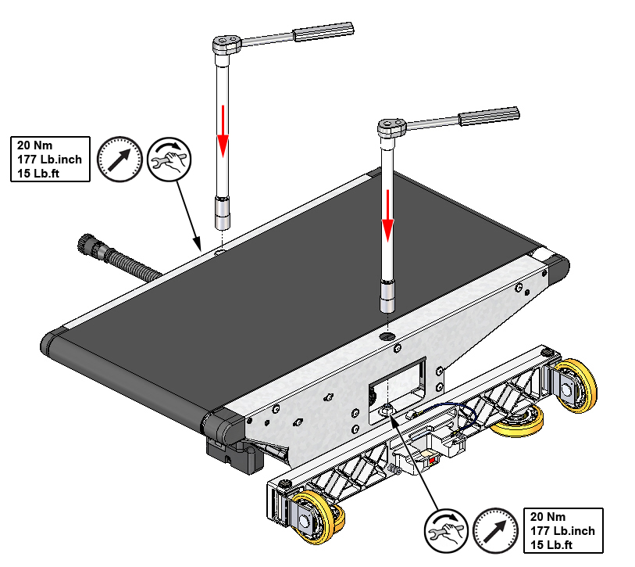
Fig. 1-7 Attachment of cross-belt unit

.5 Insert the MCB cable from the cross-belt unit behind in the socket on the cross-belt unit that has just been installed.

When plugging the connector in, it is important that the union nut is turned to the locked position, see Fig. 1-8.

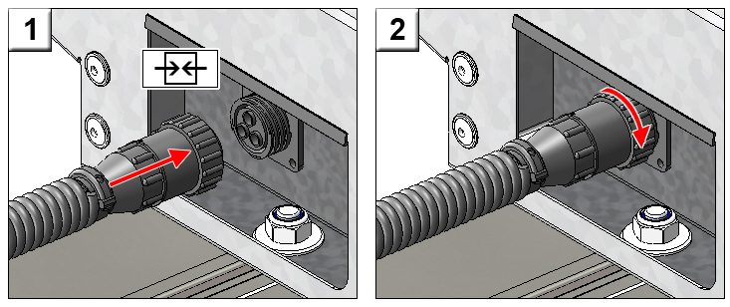
Fig. 1-8 Plugging connector on MCB cable in

.6 Continue installing cross-belt units on the other carts in the train of carts acc- to points .1 - .5.

